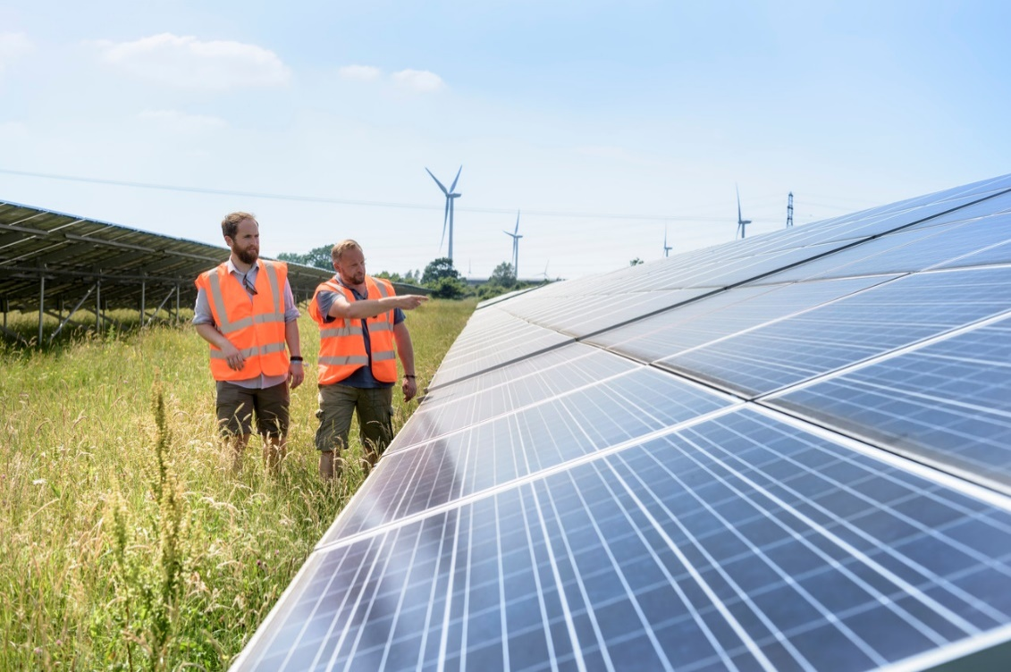
‘Digitalisation and the Net-Zero Agenda’

Foreword: Dr Peter Couch, CEO of JRC

It was a privilege to deliver this years’ JRC Annual Seminar as a virtual event for the first time and it was reassuring to see the progress that has been made by both Policy Makers and Industry to deliver upon the ‘Net Zero’ objective. It was noteworthy to see the alignment between the drive towards Digitalisation and Net Zero in particular the increasing role of enhanced Operational Telecommunications capability in enabling a ‘Net Zero’ future which is endorsed by the recent Government announcement - The ten point plan for a green industrial revolution. At JRC we look forward to working with Government and Industry to enable these objectives and particularly welcomed the contribution from the Irish regulator who outlined the importance of enabling ‘Spectrum Access’ to facilitate the ‘Smart Grid’ future.

At the Joint Radio Company’s Annual Seminar, we saw the membership discuss the latest developments on both Policy and Operational technology to facilitate the ‘Net Zero Agenda’. The timing could not have been more relevant with the release of the UK governments ten-point plan. Recognising that Utility communication systems have a key role to play in enabling the ‘Net Zero Agenda’, we also saw how there are key challenges to building an Energy system that leverages low carbon assets. Furthermore, the withdrawal of PSTN, as well as limited private industrial wireless solutions further complicates the development of a connected and robust smart grid. Whilst developments associated with 5G are gathering momentum and will over time offer increased industrial relevance, the immediate priority for Mobile Operators is improved download speeds doe consumers. The role of the communications regulator as an innovator for modern energy systems is clearly seen by the activities of the Commission for Communications Regulation in the republic of Ireland. Whilst the challenges for DNOs associated with the increasing amount of connected Distributed Energy Resources is provided by WPD. Addressing Electric Vehicles and zero carbon Domestic Heat will be and is a huge challenge. Finally, the input from UK Policy makers was key to understanding the initiatives underway to facilitate the transition to a low carbon future. Dinker Bhardwaj of BEIS advised on Government policy developments specific to Energy Market Data and the role of digitalisation in facilitating market developments. In summary, the importance of enhanced Operational Telecommunications capability in support of Net-Zero has never been greater.
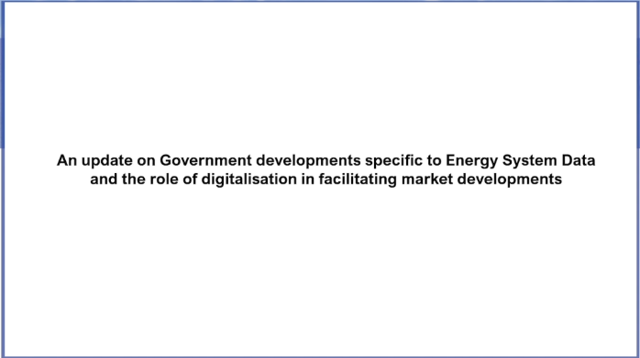
The Importance of Public and Private Collaboration to enable Digitalisations [Presentation]
To ensure stable and efficient future energy supplies there is a significant focus on the digitalisation of energy networks to address the increasingly dynamic nature of system operation and energy flows. In light of this there is an expectation that the exchange of operational data across the energy networks and between networks assets will need to be enhanced to facilitate / support the net zero carbon ambitions of Government. Dinker’s presentation addressed the Modernising Energy Data (MED) programme as it aligns to the specific outcomes being targeted by Government to ensure that Data can become accessible and exploitable emphasising the range of initiatives and activities being delivered on a collaborative basis across Government & Ofgem. Furthermore, he noted that Digitalisation of the Energy sector is a range of interdependent activities that will be dependent on Public / Private collaboration for success.
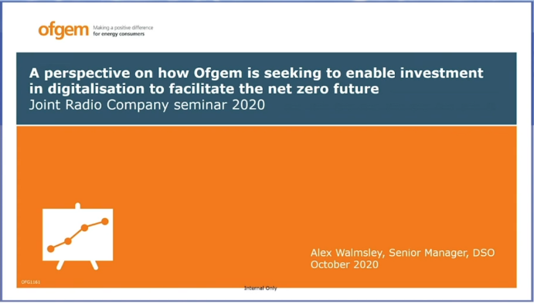
Funding the Digitalisation of the UK Energy System [ Presentation]

Alex Walmsley provided Ofgem’s perspective on how they are exploring investments to enable digitalisation to facilitate the net zero future. In so doing they are seeking to address the Industry transition from large scale energy generation to distributed renewables, whilst ensuring that customer expectations of a reliable and resilient service are assured in the context of GD2 / ED2 funding provision. Ofgem noted the importance of working with Industry and Network Operators to ensure appropriately targeted policy interventions Alex emphasised the role of innovation funding in addressing the Net Zero challenge with an emphasis on Cross Vector Projects and Whole System Initiatives. In particular Alex noted the recent consultation where Ofgem requested Industry input on the future need for greater visibility and control of Distributed Energy Resources in order to avoid systems outages, e.g. August 2019, and assure the future operational integrity of the networks.

It was great to acknowledge a clear alignment between the priority initiatives being targeted by Government and the regulatory framework under development and being targeted by Ofgem.

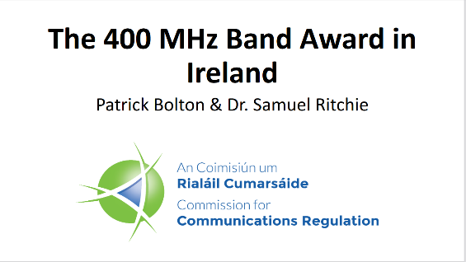
A Regulatory Intervention to facilitate Smart Grid developments – An Irish Perspective [ Presentation]
(RT – 1:05:02)

Patrick Bolton from the Irish Communications Regulator (ComReg) provided the seminar with a unique insight into how they have secured a pathway to facilitate ‘Smart Grid’ developments and the ‘net zero’ agenda in Ireland. To this end Patrick explained the approach / thinking behind the targeted regulatory intervention of spectrum release to enable facilitate ‘Smart Grid’ developments in Ireland. In particular he summarised the very robust and rigorous appraisal that resulted in ComReg and the Irish Government establishing a regulatory intervention that addressed the critical importance of targeted spectrum access for the Irish Energy Sector.

Session 2 The Industry Perspective, Challenges & Solutions
The second session was an opportunity to hear from Network Operators and the vendor community on market developments and how the industry is seeking to deliver ‘Digitalisation and the Net Zero Agenda’
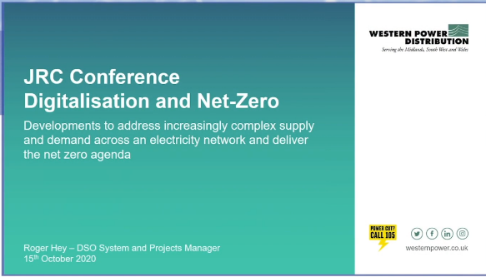
Developments at WPD to address an increasingly complex demand and supply dynamic [ Presentation]

First up was Roger Hey from Western Power Distribution who provided an insight into the developments at WPD to facilitate Low Carbon Technologies (LCTs), e.g. Distributed Energy Resources and Electric Vehicles. He noted that to address the increasing demands being placed on the operational integrity of the Electricity Networks by LCTs WPD have sought to align their Operational Strategy with the increased ability to Monitor and Control network assets and in so doing acknowledge that enhancements to Information and communications technology have been and will continue to be a key enabler of such developments. He emphasised that access to robust and real-time Data of network / asset performance enabled by robust and resilient Telecommunications systems that are ubiquitous is core to the Network Operators objectives of increasing operational efficiency and maximising the potential to leverage LCTs such as Distributed Energy Resources and in so doing serve the increasing demand for EVs and Heat Pumps. With the increased importance of real-time data informing responses by the network it was also highlighted that Cybersecurity is becoming and increasingly important aspect in maintain operational integrity and a significant focus is now being placed on ensuring that systems and operational practices are appropriately Cyber Secure working with the relevant Government Agencies. Overall it was fascinating to understand the actions underway to enable the ‘Net Zero Agenda through digitalisation’ and in particular the growing importance of enhanced Operational Telecommunications in enabling real-time data flows to support the monitoring and control response necessary to deliver a more dynamic energy supply solution.
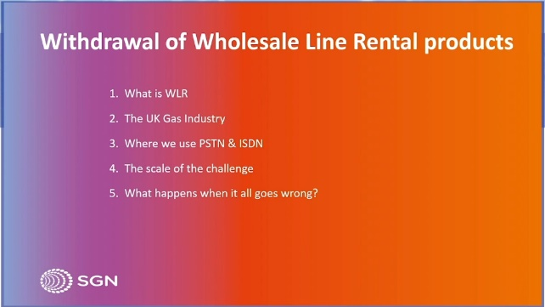
SGN and the Challenges posed by PSTN Withdrawal [ Presentation]
Our second set of speakers were from Scotia Gas Networks (SGN) and they explored the challenges being presented by the planned withdrawal of the legacy fixed line telephone service provided by Openreach. This infrastructure is utilised by the gas network operators to monitor and control operational network assets across the UK and these Telemetry systems ensure the operational integrity of the Gas networks and the dependable supply of Gas to consumers. In the context of the Net Zero Agenda and Digitalisation the planned withdrawal of the PSTN solution is requiring the Energy Network operators to establish alternative solutions that are capable of facilitating operational data and respond to control prompts in remote locations. Furthermore, in the context of Gas networks it was noted that one of the attributes of the PSTN solution which is proving difficult to replicate is the resilient power that accompanies a PSTN circuit and is not available via the alternative fibre based solutions. Overall, the PSTN withdrawal process further emphasises the increasing importance of resilient and robust operational telecommunications solutions to ensure the efficient and safe supply of energy to UK Consumers. Furthermore, SGN emphasised the significant disruption and investment that will be required to secure the operational integrity of the Energy Networks over the long term.
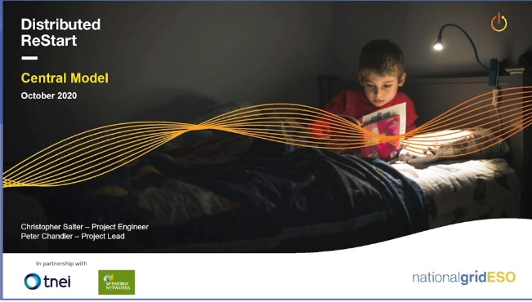
Distributed ReStart and the Central Model [ Presentation]
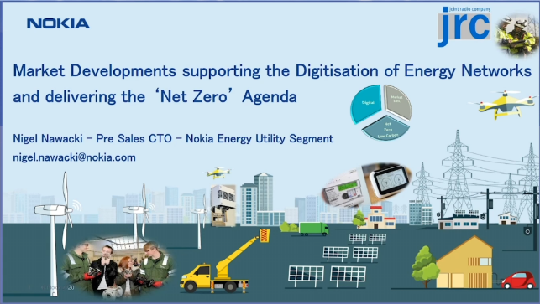
Chris Salter was third up from the Distributed ReStart Project and he offered an update on the latest thinking from this project which is seeking to establish an operational approach to the use of Distributed Energy Resources (DER) to restart the Energy Networks in the event of a National or Regional power outage. In particular, he noted the logistical / operational complexity of co-ordinating a significant number of dispersed assets predominantly connected to the Distribution Operators’ Networks. Core to enabling such an approach is the establishment of robust and resilient systems and communications capability to remotely dispatch DERs both via manual and manual methods based on a carefully orchestrated plan co-ordinated between National Grid Electricity System Operator and the relevant Distribution Network Operators – the approach being adopted is the Central Model. Through this innovative project NGESO alongside SPEN are establishing an approach whereby DERS will be able to support Black Start requirements and in so doing secure a pathway to a Net Zero Black Start solution whilst recognising the critical role of enhanced communications capability will have in enabling such a solution.
Embracing the Low Carbon Future and the importance responsive Operational Telecommunications capability to respond in real-time to demand and supply imbalances across Energy networks [ Presentation]
Nokia offered a detailed insight into the need for enhanced operational telecommunications capability to be embedded alongside the Energy Distribution Networks to facilitate the ‘Net Zero Future.’ In particular it was noted that the increase in the number and diversity of generation sources connected at the Distribution layer will be dependent on a much more responsive control system that is more sensitive and responsive to network supply and demand changes and hence an Operational Telecommunications system that is more dynamic and responsive than existing solutions will be necessary – without such a development the Net Zero Future will not be realised.
Thought Piece: Nigel Nawacki, Energy / Utilities Operational Sales CTO EMEA Nokia
This year the JRC 2020 seminar offered a view from Policy Makers and Industry towards policy that enables the NetZero grid. It was an honour to have provided an insight into how operational telecommunications capability has an increasing role in the monitoring and control of grid assets. The co-ordination / administration of increased renewables as a connected system was key. The connectivity of new grid supply and Electric Vehicles needs to be supported by telecom systems in a stable supply / demand “system” context. This is equally applicable to Gas, Water and Power transmission or distribution. To this end it is worth reflecting on the ‘smart energy blind spot,’ https://networks.online/gas/the-smart-energy-blind-spot/ ,and the importance of enabling appropriate Policy interventions to facilitate the right operational control. Net-Zero will not be delivered without Spectrum Access and enabling systems in Operational Telecommunications based on Industrial 3GPP Wireless. This is to provide the scale and to provide an easy medium for alternatives to legacy Fixed Telecommunications where ageing copper systems are to be replaced.

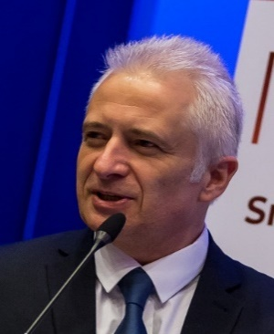

Gas is an explosive material and Gas Network Operators have designed their monitoring and control capability tom minimise the risk posed by mains electricity

